Platform For Solid Waste Management System

***Author*** *Avinash Singh*

***Change History*** *Version 1.0  
20 Feb 2022*

***Overview of challenges in SWM*** *Urban India generates 62 million tonnes of waste (MSW) annually, said a 2014 Planning Commission report. It is also predicted that the volume will increase to 165 million tonnes by 2030.  
  
India’s solid waste collection efficiency, however, is around 70 percent at present, while it is almost 100 percent in many developed countries.  
  
Moreover, 43 million tonnes of municipal solid waste was collected annually, out of which 31 million were dumped at the landfill sites and 11.9 million were treated, the environment ministry said in 2016.  
  
A huge portion of the untreated waste is dumped irregularly on the outskirts of towns or cities, causing groundwater contamination and air pollution. There is, thus, a growing need to detect blind spots in the collection and transportation of waste so that the operation can be made more efficient  
  
‘For any region, SWM has issues like Non-participation of households, trade & commerce, Lack of sufficient knowledge on benefits of waste segregation at source, Lack of proper & timely communications, No real-time tracking & monitoring of Drivers/Vehicles, Irregular collection, and transportation facility.’*

***Validation of Challenges*** *The above-mentioned challenges will be validated through primary and secondary data. Primary data will be collected using questionnaires for surveys of various stakeholders, one-to-one and online, interviewing citizens, and using empathizing techniques to find a better solution. The secondary data will be used for understanding the volume of impact using data available with government and research centers. This collected data will be used to identify the user and analyze the utility of the solution built.  
  
The whole process of solution building will be done in the following steps:  
  
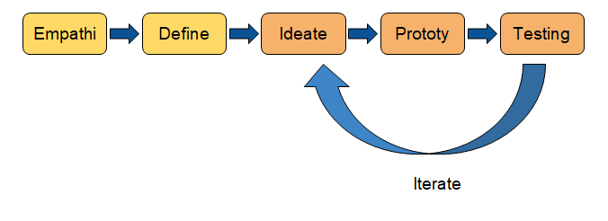*

***Solution*** *Note: This solution is on the basis of secondary data collected from various government websites.  
  
A platform is required in order to assist in keeping the city clean, in which various actors are present, like citizens, vendors, urban local bodies. This platform will also ensure a smooth flow of activities like segregation, collection, transportation & disposal of waste. A smart, integrated waste management system will ensure real-time monitoring of the collection and transportation of waste.****How this will help*** *If we look at challenges and issues in the waste management system, we can observe that major causes of these are high amounts of waste generation, non-segregated waste, this leads to lack of space for landfills and a high volume of untreated waste. It is also noted that there are a lot of waste materials that can be reused before even being treated as waste.  
  
There are places and bins where the waste is thrown for months, leading to an increase in diseases in the area and the creation of unapproved/illegal landfills. This happens majorly because the staff is unaware of these newly created landfills and the condition of the bins. All these causes can be addressed with just aware citizens and staff. An aware citizen will help the system to follow the tunnel of waste management( see below figure), which will eventually lead to a decrease in volume and type of waste generation at source.  
  
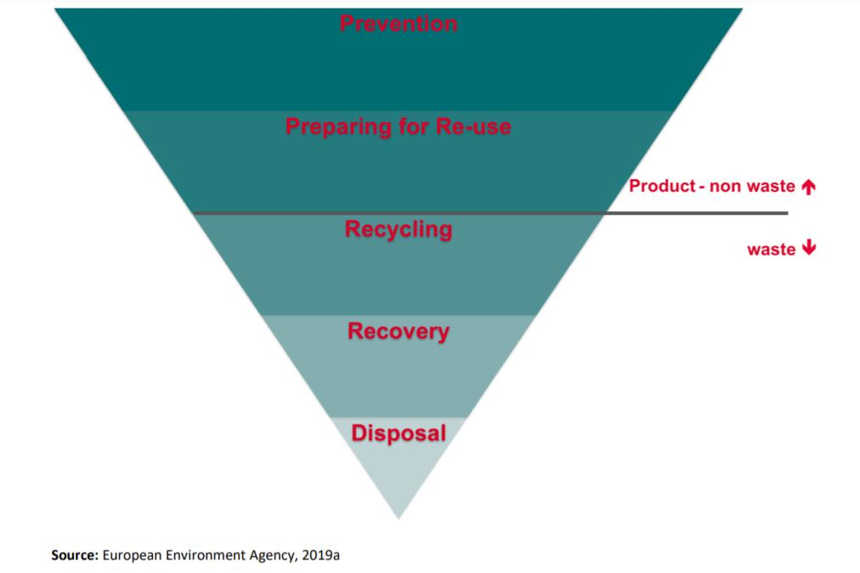  
  
An aware staff will help to attain following leading to efficiency in waste management system:  
● Central management & control  
● Operational efficiency & improved service quality  
● Immediate intervention capability through real-time alerts  
● Increased employee productivity  
● Increased customer and citizen satisfaction*

***Objective*** *● To develop a platform for SWM to assist the efficiency and smooth flow of activities from the pickup of the waste to the point of disposal.  
● To collect data, monitor, and analyze the activities involved in the Solid Waste Management System*

***Platform for SWM*** *The platform is divided into 3 parts: a website for ULBs and Vendors, an app for the on-field workforce, and an app for the citizens and activists.  
  
Below is the breakdown of the platform along with key features.  
  
Static Pages  
1. Guidelines  
2. SWM knowledge base  
3. Archive to display all uploads  
4. Notice Board for Notification  
  
ULB Dashboard  
  
1. UI Design  
2. User profile  
3. Login for dashboard  
4. Position and route tracking of Garbage vehicle  
5. Report analysis  
6. Grievance control system  
7. Report control system for SLA breach  
8. Assets Monitoring  
  
Vendor Dashboard  
  
1. UI Design  
2. User Profile  
3. Login for Dashboard  
4. Task Assignment  
5. Pickup Points  
6. Vehicle allocation  
7. Attendance Monitoring  
8. Vehicle location Monitoring  
9. Asset condition reports  
10. Alerts for staff  
  
Citizen app  
  
1. UI design  
2. User Profile  
3. User login  
4. Ticket Management with location  
5. SWM Gamified Knowledge  
6. Pickup timing  
7. Report section  
8. Facts section  
  
App for Staff  
  
1. UI Design  
2. User Profile  
3. User Login  
4. Task Section  
5. Route Section  
6. Attendance monitoring  
7. work status*

***High-Level Requirements*** *ULB Dashboard*

|  |  |  |  |
| --- | --- | --- | --- |
| **Requirement Number** | **Requirement Description** | **Notes** | **Category** |
| 001 | ULB will be able to track the position and routes of the garbage vehicle |  | Transportation |
| 002 | ULB will be able to view an analysis report in order to check the number of staff employed and their attendance on daily, weekly, monthly and yearly basis |  | Transportation Disposal and Treatment/Processing |
| 003 | ULB will be able to see and respond to the complaints tickets of the consumer |  |  |
| 004 | ULB will be able to see and respond to the complaints tickets of the vendor |  | Transportation Disposal and Treatment/Processing |
| 005 | ULB will be able to see delivery analysis reports of all pick-up points in order to see any breach in SLA. | This will be high in terms of time or non serviced pickup points |  |
| 006 | ULB will be able to send instructions to vendors |  | Transportation Disposal and Treatment/Processing |
| 007 | ULB will be able to view the number of active (on-field) assets |  | Transportation Disposal and Treatment/Processing |
| 008 | Platform will have a notice board to display any new guidelines from the ULB |  | Transportation Disposal and Treatment/Processing |
| 009 | Platform will have archive section to display all the documents uploaded till date |  |  |
| 010 | ULB will be able to monitor the activities of Transportation facilities, Disposal Facilities, and Treatment/Processing Facilities |  | Transportation Disposal and Treatment/Processing |
| 011 | ULB will be able to see the report on weight and categories of Waste Collected |  | Treatment/Processing |

Vendor Dashboard

|  |  |  |  |
| --- | --- | --- | --- |
| **Requirement Number** | **Requirement Description** | **Notes** | **Category** |
| 001 | Vendor will be able to assign tasks to individual employees |  | Transportation Disposal and Treatment/Processing |
| 002 | Vendor will be able to see SLA for particular Pick up point |  | Transportation |
| 003 | Vendor will be able to redirect any vehicle from its route by sending instructions |  | Transportation |
| 004 | Vendor will be able to allocate the vehicle to the particular Driver |  | Transportation |
| 005 | Vendor will be able to monitor the staff attendance |  |  |
| 006 | Vendor will be able to track and monitor the location of all the employed vehicles via GPS |  | Transportation |
| 007 | Vendor will be able to view the report on service and condition of all the asset employed |  | Transportation Disposal and Treatment/Processing |
| 008 | Vendor will be able to view SLA of all the pickup points |  | Transportation |
| 009 | Vendor will be able to schedule the routes and time for all pickup points |  | Transportation |
| 010 | Vendor will be able to view the status of service of all the pickup points |  | Transportation |
| 011 | Platform will send alerts in case of a breach in SLA is detected | In terms of transportation ● For Example: In case the SLA for a pickup point is till 10 am. ● At 9:30 am the Vehicle associated with the pickup point is 45 mins away from the location. ● In this scenario, the system will send alerts to the dashboard stating possible breaches in SLA. | Transportation |

App for Citizen and Activists

|  |  |  |  |
| --- | --- | --- | --- |
| **Requirement Number** | **Requirement Description** | **Notes** | **Category** |
| 001 | Users will be able to report complaints using ticket system |  |  |
| 002 | Users will be able to click the photo in order to attach a grievance. | This Photo will be sent along with information of the location where the photo was clicked using the GPS System. |  |
| 003 | Users will be able to learn about Solid Waste Management practices via short courses | This will be delivered in the form of short courses of maximum read minutes of 5min. Learning will be in form of facts and quizzes |  |
| 004 | Users will be able to track their learning progress |  |  |
| 005 | Users will be able to see arrival timing of the pickup cleaning vehicle for a particular pickup point | For Industry, commercial buildings |  |
| 006 | Users will be able to see schedule and arrival timing of informal staff for collection of waste | For Household and Apartments - door to door collection |  |
| 007 | Users will be able to see the report and facts about the cleanliness of their area on a daily basis. |  |  |
| 008 | Users will be able to review and give feedback on the service and cleanliness of their City. |  |  |

App for Staff

|  |  |  |  |
| --- | --- | --- | --- |
| **Requirement Number** | **Requirement Description** | **Notes** | **Category** |
| 001 | Staff will be able to see the schedule on Daily Basis |  | Transportation Disposal and Treatment/Processing |
| 002 | Staff will be able to see tasks assigned to them individually. |  | Transportation Disposal and Treatment/Processing |
| 003 | Staff can see the best route for several pickup points |  | Transportation |
| 004 | Staff will receive alerts in case of any changes in assigned routes or pickup points |  | Transportation |
| 005 | Staff will be able to mark their attendance on a daily basis | For Transportation Facility Staff: ● The attendance will be marked only when proof of service will be updated. ● Proof Service: Upload (before and after) photographs of all pick-up points and the GPS system verifies that they have crossed all the pick-up points. | Transportation Disposal and Treatment/Processing |
| 006 | Staff can check their profile | Staff ID, Details of the vehicle assigned, etc | Transportation Disposal and Treatment/Processing |

***Wireframe*** *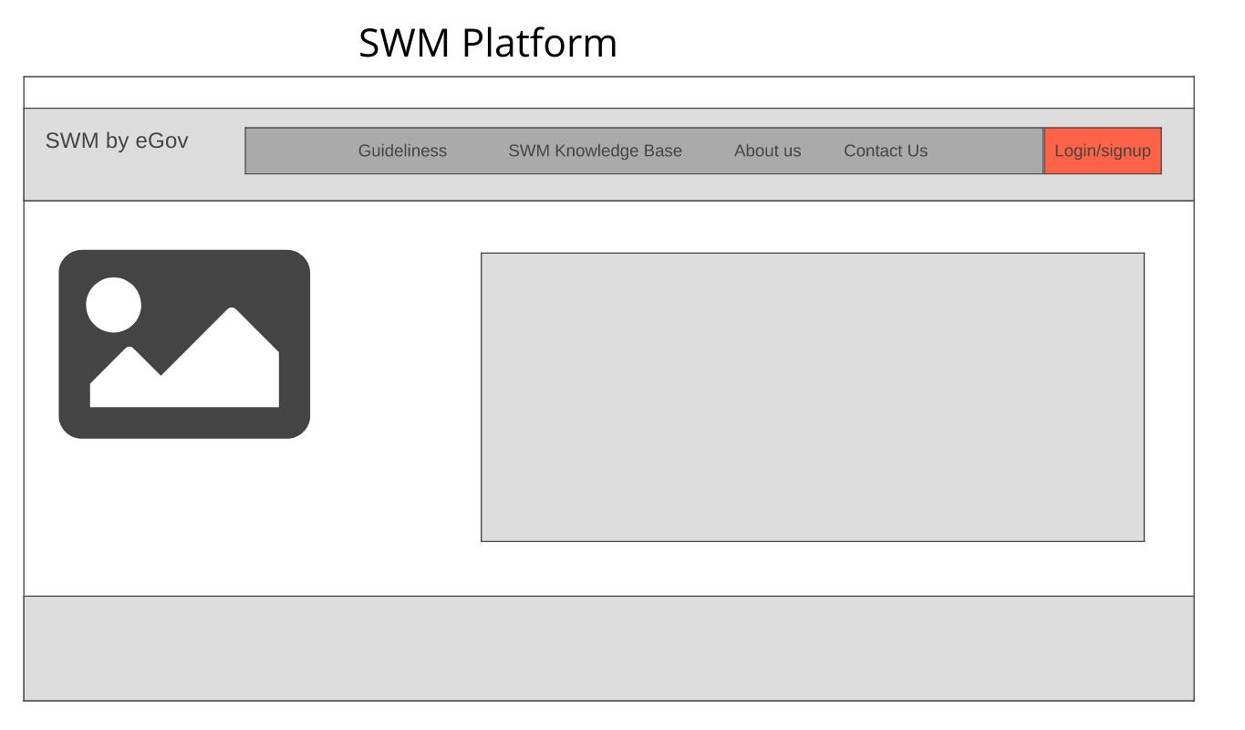  
  
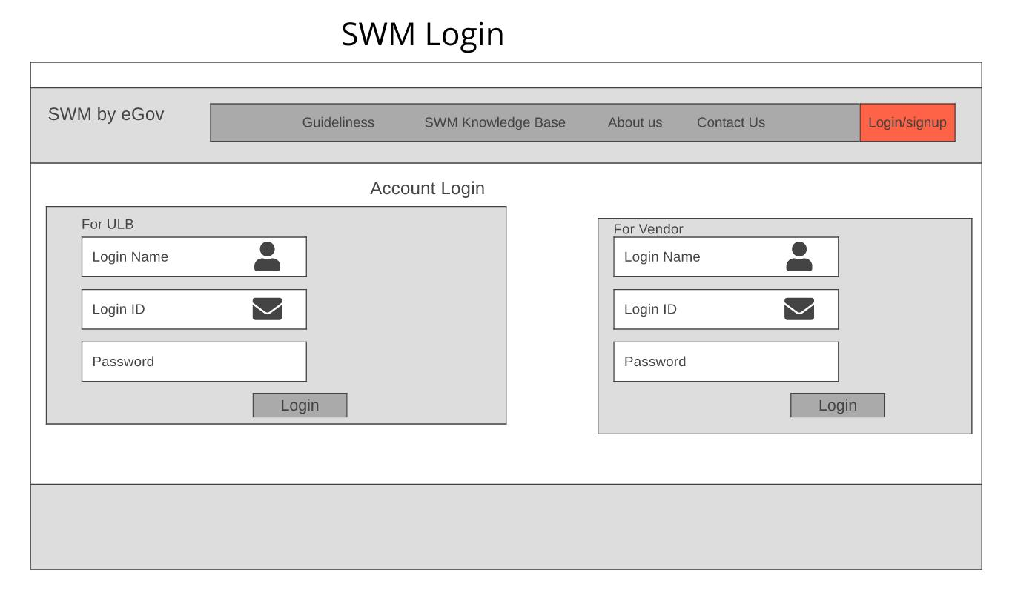  
  
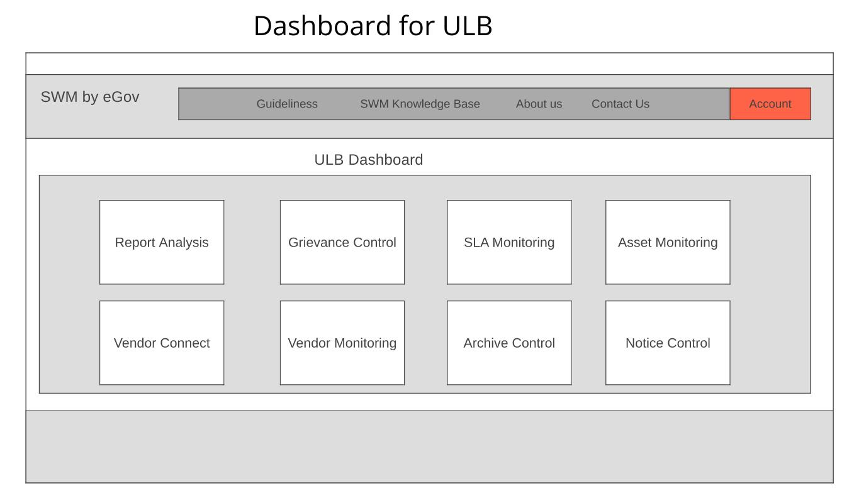  
  
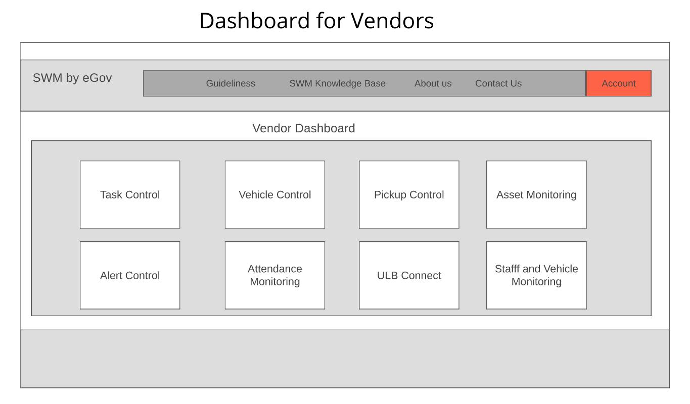  
  
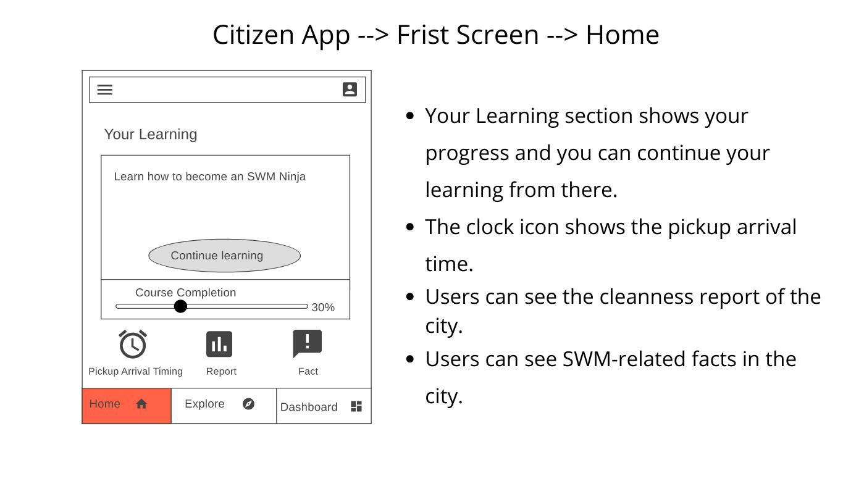  
  
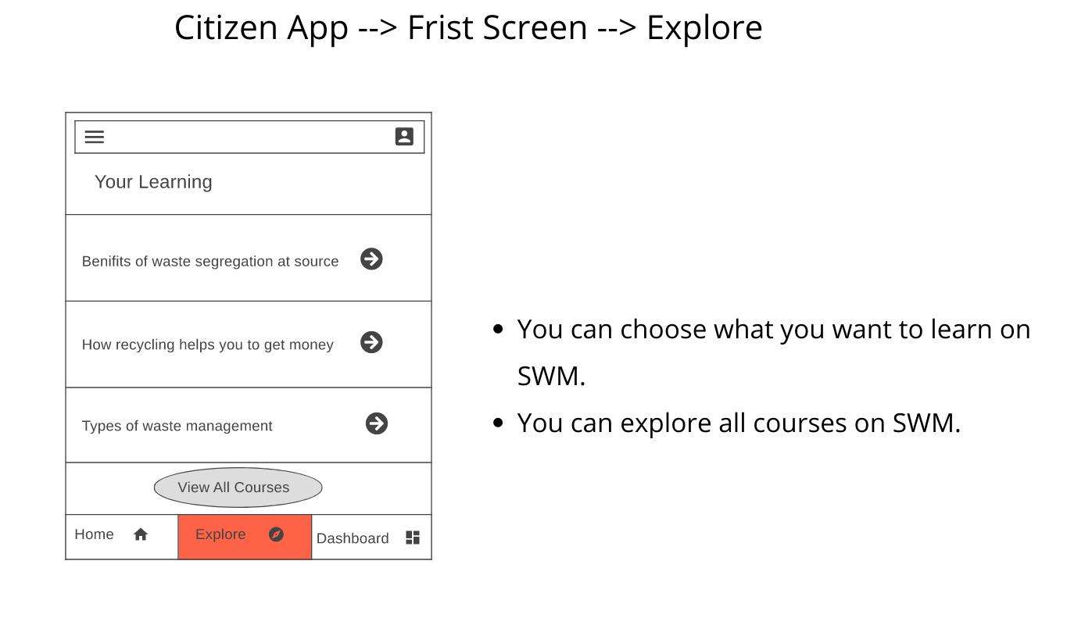  
  
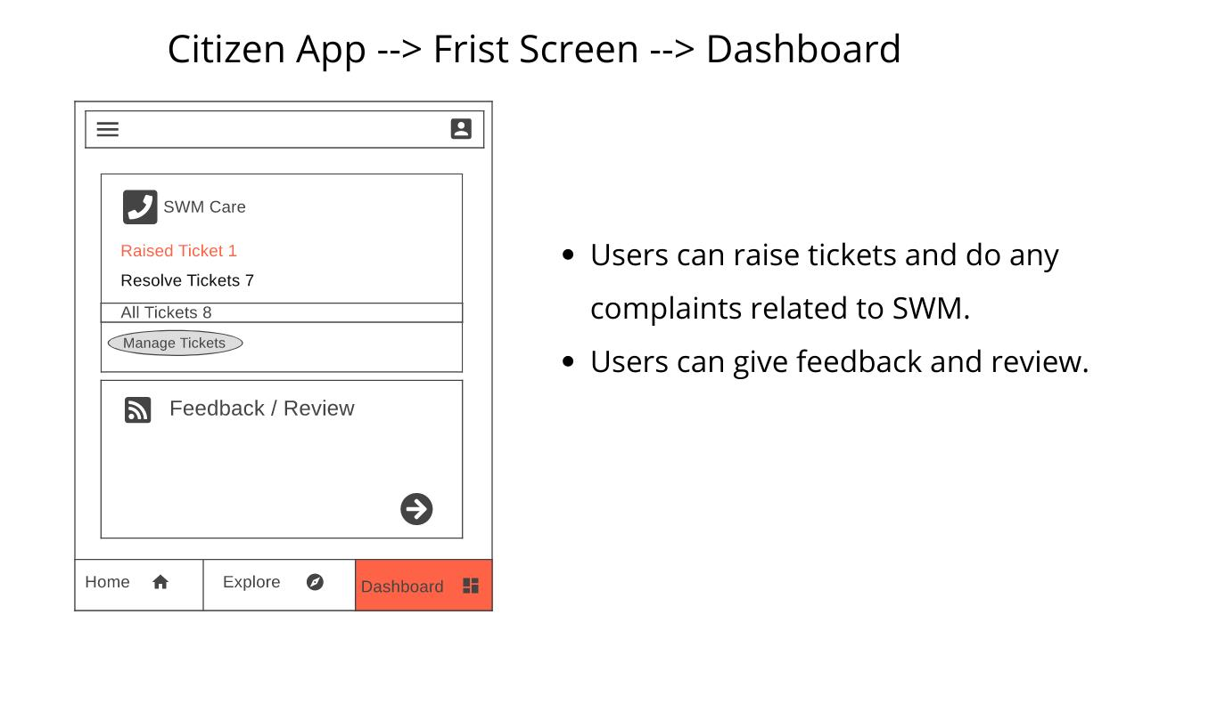  
  
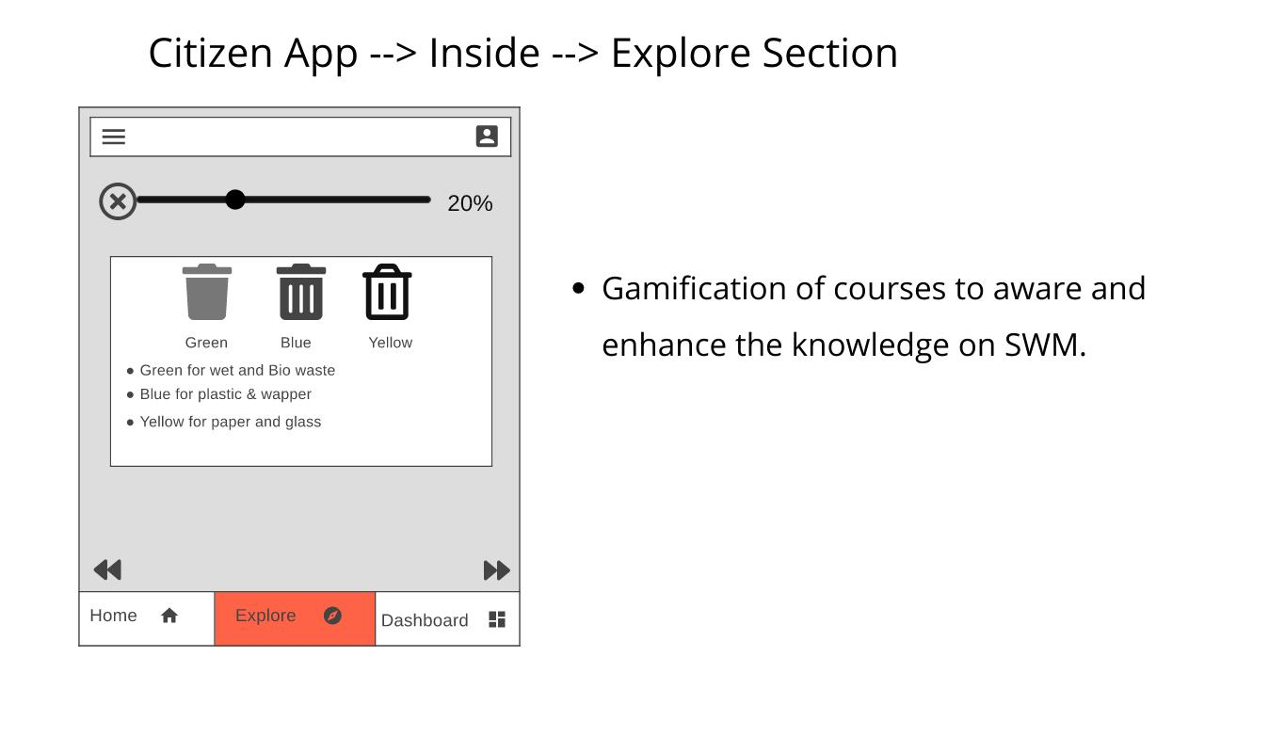  
  
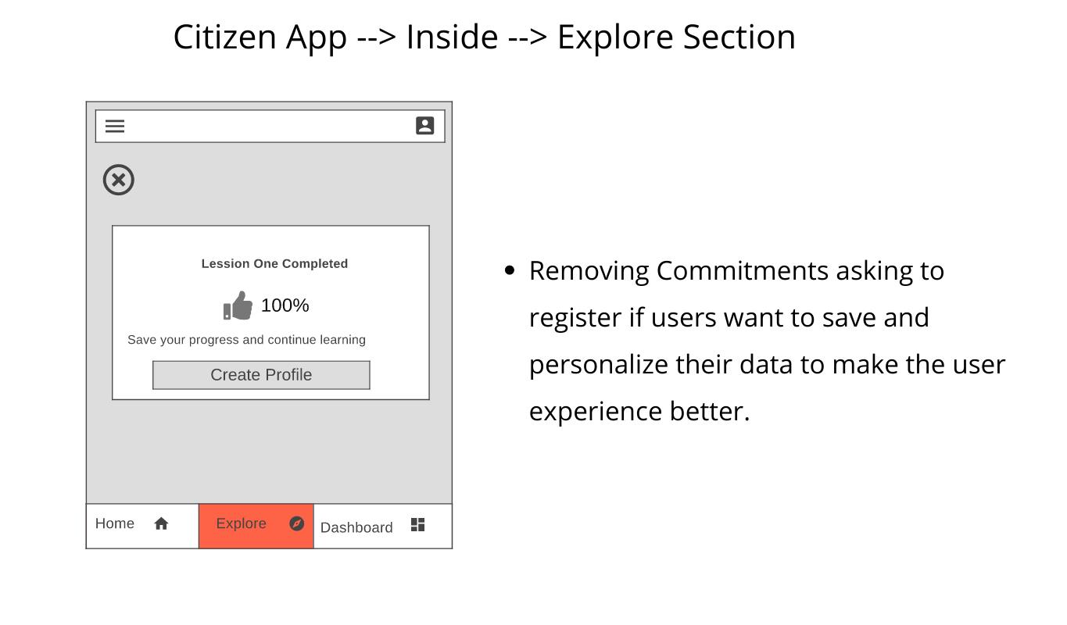  
  
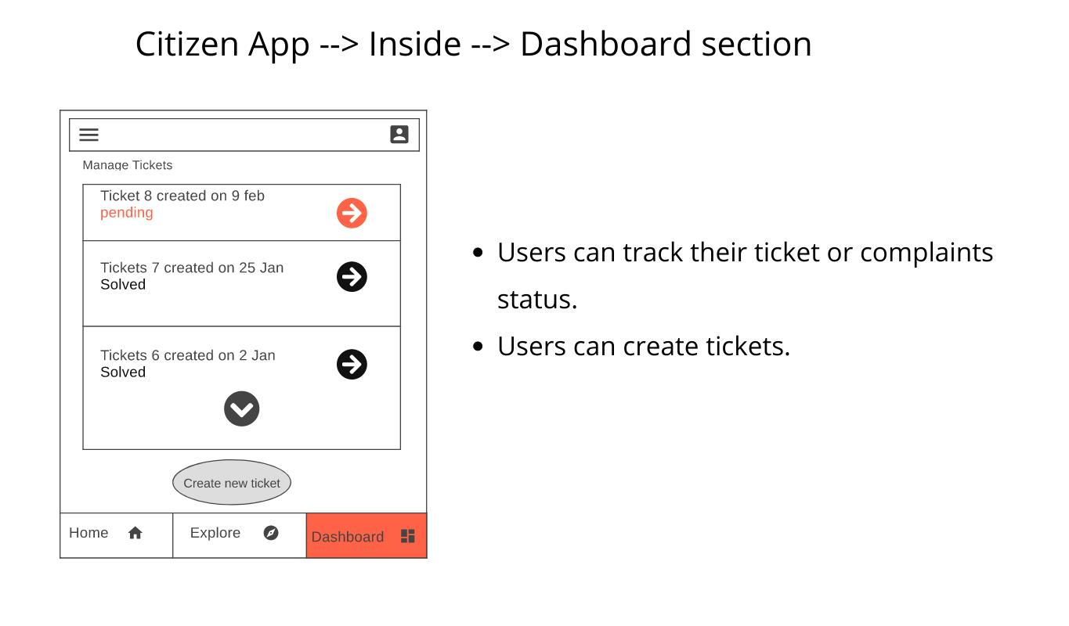  
  
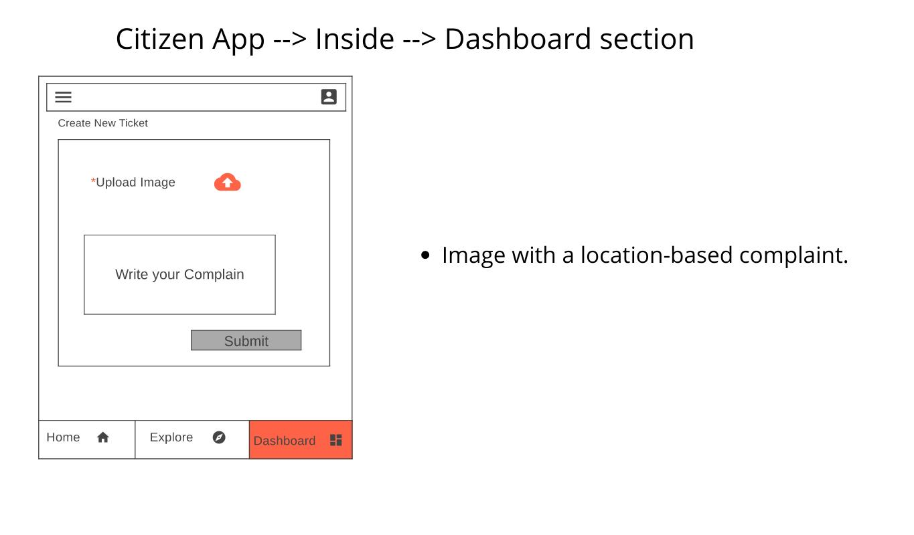  
  
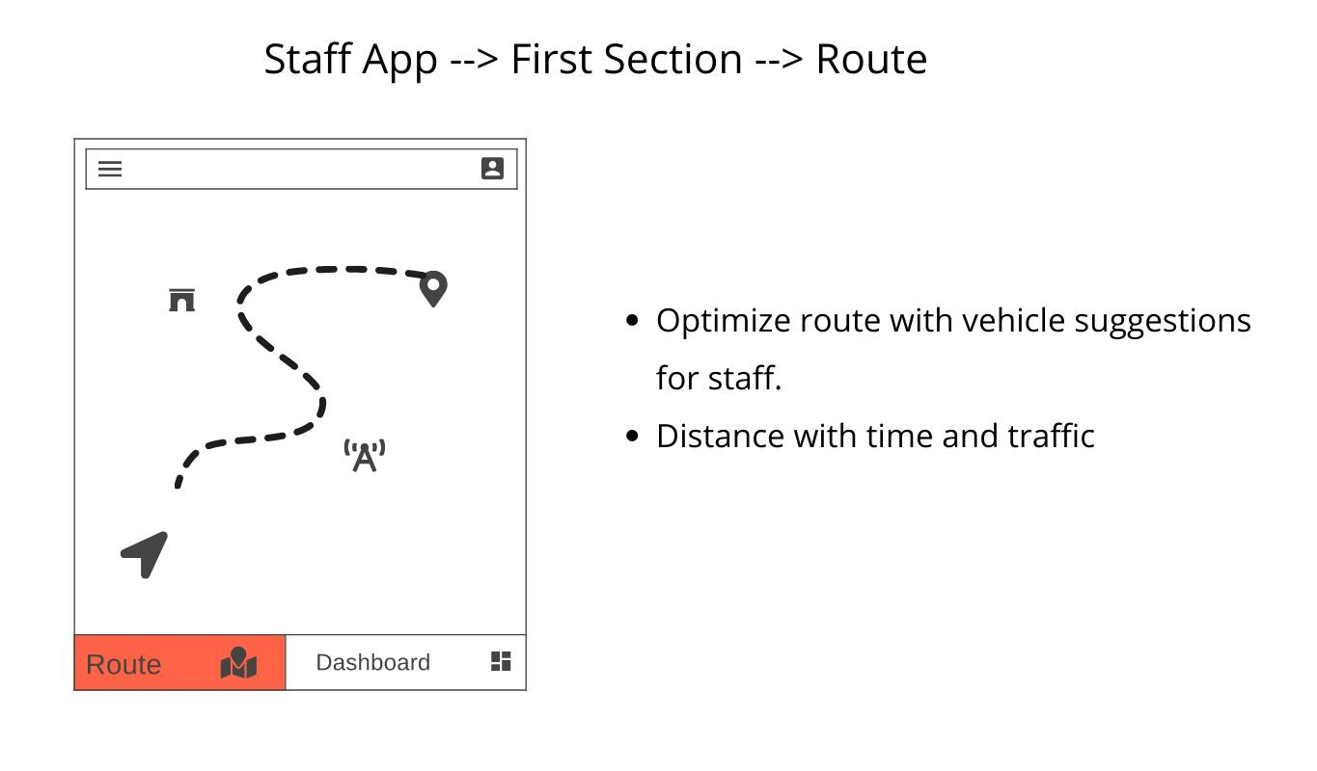  
  
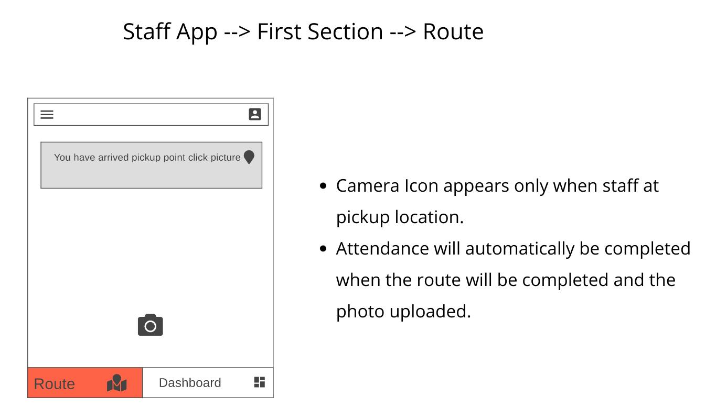  
  
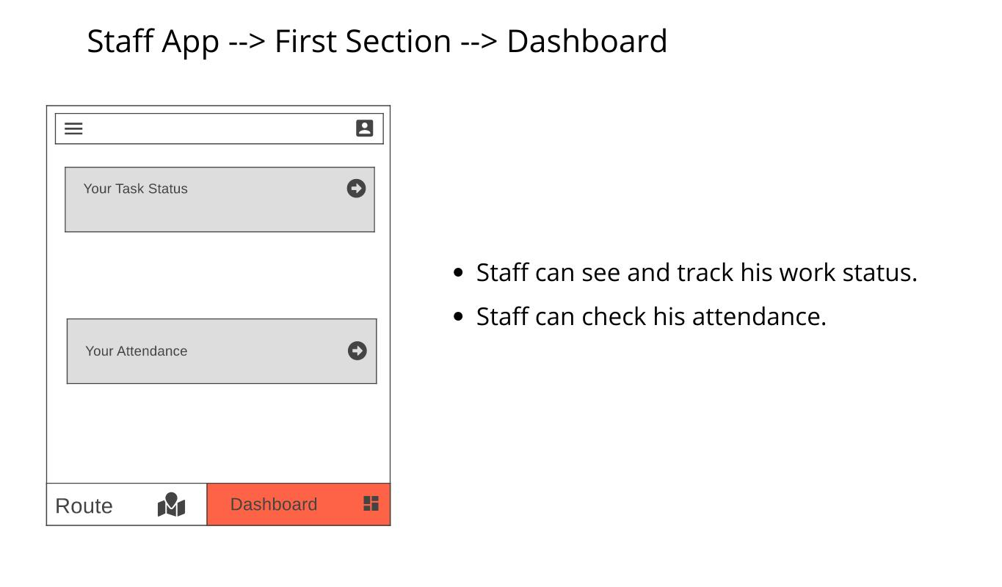*

***Roadmap*** *Note: Kindly zoom for a better view.*[*Click Here to view Roadmap*](https://avithehacker.github.io/PM/old%20website/swm.html)

***KPI***

|  |  |
| --- | --- |
| **Area of Focus** | **Measurable Metrics** |
| Time consumption due to real-time monitoring of Vehicles | 100% communication is happening in real-time without any delay |
| Completion of SLA post the implementation of platform as compared to prior case | 95% of Vehicles are able to complete tasks within SLA |
| Awareness (via App) | 50% segregation happens at source (at household and apartments) |
| Grievance Redressal System | Tickets are resolved timely (within SLA) |
| Monitoring data and optimization route | Stakeholders are able to track and monitor the routes of 100% of the vehicles on road. |

***Project Success Criteria***

|  |  |
| --- | --- |
| **Area of Focus** | **How to reach it** |
| Development of Platform | Regular discussion Meetings, Daily Standup Meetings, Active Stakeholder involvement throughout the development process, Releasing MVPs |
| Segregation at source | Gamification of courses regarding waste management System for citizens |
| Lesser Challenges | Validation, Regular Surveys pre and post-implementation of Platform |
| Awareness among Staff | Real-Time view of job card via app |
| Efficient control of source system | Real-Time monitoring and analysis of activities. |
| Increase in recycle of materials | courses regarding waste management System for citizens |

***References*** *●*[*https://economictimes.indiatimes.com/news/science/how-to-transform-waste-management-using-ict-to-enable-swachh-bharat-mission/articleshow/47957702.cms?from=mdr*](https://economictimes.indiatimes.com/news/science/how-to-transform-waste-management-using-ict-to-enable-swachh-bharat-mission/articleshow/47957702.cms?from=mdr) *●*[*http://cpheeo.gov.in/upload/uploadfiles/files/Part3.pdf*](http://cpheeo.gov.in/upload/uploadfiles/files/Part3.pdf) *●*[*https://www.adb.org/sites/default/files/institutional-document/324101/tool-kit-solid-waste-management.pdf*](https://www.adb.org/sites/default/files/institutional-document/324101/tool-kit-solid-waste-management.pdf) *●*[*https://www.ccacoalition.org/en/initiatives/waste*](https://www.ccacoalition.org/en/initiatives/waste)